Risk Assessment Coaching

Name of Coach |  |  |  | Name of other adult supervisors | Date of risk assessment
Declan Acornley |  |  |  | N/A | 07/11/2023
Name of Event/Activity |  |  |  | Number of Children | Date(s) of Event/Activity
Private Coaching |  |  |  | As required and within supervision ratio. | As required
Hazard | Who at risk | Initial Risk Score  (L / M / H) | Control Measures |  |  | Mitigated Risk Score (L / M / H)
Risk of inappropriate adult left supervising children. | Children | M | - Coach must hold a valid membership of LTA Coach Accreditation level 2-5  - It is our coach’s responsibility to purchase and maintain their LTA Coach accreditation.  - By holding coach accreditation coaches will have completed the required checks and training:  Safeguarding training First Aid Training  Criminal record check (Enhanced DBS)  - Applicants for a coach position will have been recruited according to our recruitment policy and two references obtained detailing the applicant’s suitability to work with children.  - Our coach does not have sole responsibility for supervising children as parents are asked to be on the premises/within view when children are being coached. |  |  | L

Risk of incidents arising from unsupervised children | Children | M | - All adult supervisors will hold an up-to-date Enhanced DBS and have completed basic awareness safeguarding training.  - Volunteers will be briefed about their roles, responsibilities, and any specific risks about which they should be aware. Emergency contact information shared.  - Volunteers will ensure they have read and always uphold the LTA Safeguarding Policy and Reporting Procedures (www.lta.org.uk/safeguarding)  - Coach to ensure that supervisors are competent for the scope of the specific event/activity undertaken.  - Minimum staff/player ratios will be:  - 2:8 for children 10 and under  - 2:10 for children aged 11 and over.  - Children will be accompanied by their own parent or supervisor to any public toilets (for non- public toilets, the member of parent will wait nearby and in direct line of sight of the toilet).  - Players are briefed about appropriate conduct (including the code of conduct) and specific risks about which they should be aware.  - Parental consent is obtained for all visits that require transport, plus a completed consent and emergency contact form.  - The Lead Adult will ensure that the proposed locations for the visit are suitable for the activity and manageable for the group. | L
Emergencies, medical issues, and accidents | Adults Children | M | - Dec Acornley is a qualified First Aider.  - Ratios of adult supervisors/parents to children will allow for dealing with emergencies that require the group to split up.  - Consent process includes specific medical/medicinal information, dietary requirements, and emergency contact details.  - Defibrillator available on the outside of the LVM S&SC building when at Longton home ground.  - Emergency contact information for each child must be known to coach/supervisor.  - Emergency contact information for adults and children taken on the membership form.  - Event timetable, location and coach/supervising adult contact details known to emergency contacts.  - Players briefed in what to do should they become separated from the group.  - Any specific medical needs have been considered. | L

Adverse weather | Adults Children | M | - Weather forecast checked ahead of coaching session/event and program adjusted accordingly.  - Where over-exposure to the sun is possible, sun block carried (at least SPF30) and administered by the children themselves.  - Access to bottled drinking water available  - Suitable breaks out of the sun ensured in the timetable for the day.  - Suitable warm blankets available during cold/wet weather.  - Play to be suspended during adverse weather as judged by the coach or supervising adult. | L
Risk of abuse and bullying | Children | M | - All adult supervisors will hold an up-to-date DBS and have completed basic awareness safeguarding training.  - All adult supervisors will be aware of and comply with the safeguarding policy and procedures.  - Children and parents will be given information on safeguarding and informed of who to report any concerns to  - ChildLine and NSPCC numbers will be shared with staff, parents, and children.  - Minimum staff/player ratios will be:  - 2:8 for children 10 and under  - 2:10 for children aged 11 and over.  - Communication with children through electronic devices will be conducted in accordance with the Online Safety and Communication Policy.  - Children required to complete and return the acceptable use statement for internet and social media use.  - All adult supervisors comply with the anti-bullying policy | L
Inappropriate transportation methods | Children | M | - All transportation has been formally agreed for the purposes of the trip.  - Minimum of two adult supervisors will travel in the vehicle with juniors always sat in the back (in emergency situations it may be necessary for one adult supervisor to drive a child to a hospital).  - Parents and children will be informed of the destination, reason for the journey and who the driver and second adult supervisor will be.  - Parents will have provided a consent form confirming they are happy for their child to be taken in the car.  - Drivers will have a valid UK driving licence, satisfactory DBS check (if applicable), MOT  certificate, road tax and insurance. | L

 |  |  | - All travellers will comply with laws on the use of seatbelts and restraints.
Inappropriate photography, filming, and social media activity | Children | M | - Club photography policy in effect/adopted.  - Club online safety and communication policy in effect  - All adult supervisors on trip familiar with the LTA photography and filming best practice guidance.  - Children required to complete and return the acceptable use statement for internet and social  media use. | L
Missing children | Children | L | - Missing player flowchart known to coach and supervising adults.  - Venue management details have been ascertained in advance.  - Contact details for all children mobile devices available to hand if they get separated.  - Children informed of venue meeting points / where to go if they get separated.  - Emergency contact details for all children have been obtained. | L
Inappropriate use of changing facilities | Adults Children | L | - Children will come to the event changed and ready to play and will shower and change back at home.  - We do not have changing facilities for adults or children, and everyone arrives dressed ready to play so there is no inappropriate use. | L
Late or non- collection of children by parents/carers | Children | M | - Collection arrangements discussed and agreed in advance with parents, including the process that will be followed in the event of non-collection.  - Significant/repeated concerns about timekeeping and non-collection are raised to the Club Welfare Officer.  - A record of late or non-collection should be emailed to welfare officer and kept on file. | L
Children misbehaving and disrupting coaching sessions. |  | M | - Coach must hold a valid membership of LTA Coach Accreditation level 2-5 and therefore be trained to manage situations which may arise during coaching sessions.  - Coach is familiar with the LTA Code of Conduct.  - Children must agree to treat each other with respect and follow our anti bullying policy together with our acceptable use statement for internet and social media use. | L

- If a child is exhibiting challenging behaviour which is a risk to other children, the coach/parent and welfare officer will agree strategies to manage the risks and support the child. Unfortunately, if the child continues to present a high risk to himself or others, they may be asked to leave the coaching group.
Other (detail)

Name of Coach  Dec Acornley | Signature: | Date:  07/11/2023
Name of Welfare Officer / County Safeguarding Officer (delete as required):  Allison Moosa | Signature:  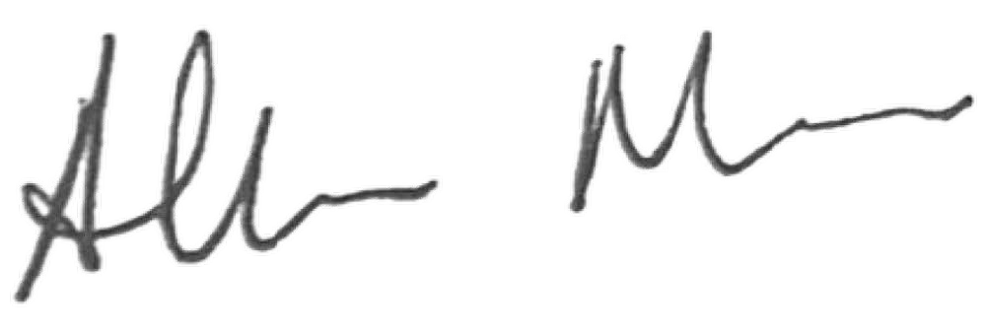 | Date:  07/11/2023

